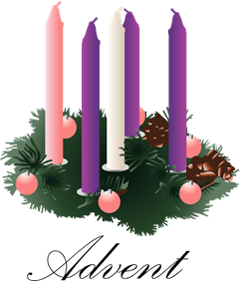
Advent
Good Shepherd United Methodist Church
December 20, 2020 10:30 am Order of Worship
worship in the time of social distance
Prelude: Elevation, A. Guilmant Dr. Larisa Soboleva, Music Director
Greeting
Lighting of the Advent Wreath - The Candle of Love
Luke 1:46-55
O Come, O Come Emmanuel #211 vs 4
Call to Worship 2 Samuel 7, Luke 1:47-55, Luke 1:26-38 Worship Leader
Leader: Host of Hosts, from sunrise to sunrise, and generation to generation, we are
your people.
People: You have been with us wherever we have gone. You will be with us
wherever we may go.
Leader: You planted us in a land flowing with milk and honey, then you planted our
salvation in Mary’s womb.
People: Jesus, who is the Christ, is planted firmly in each one of us.
Leader: Our souls magnify the Holy One.
People: Our spirits rejoice in God, our Savior.
Opening Prayer Worship Leader
Mighty God, pour out your Holy Spirit on all of us gathered here. As we follow in Mary’s footsteps, open our hearts, that we might be filled with your goodness and your love. Live in us, that we might bear the Christ light for all to see. Over-shadow us with your presence, that we might truly be blessed and offer your blessing of love to the world.
Hymn: Love Came Down at Christmas #242 Listen as Carol Ghenic & Linda Gottron sing
Scripture: Luke 1: 26-38 Worship Leader
Leader: This is the word of God for the people of God
People: Thanks be to God
Sermon: Loved Instead of Lost Rev. Stephen K. Perrine
Offertory: Offertory No.1, A. Guilmant
Doxology Hymnal #95 Listen as Carol & Linda sing
Pastoral Prayer
Lord’s Prayer
Hymn: It Came upon the Midnight Clear #218 Listen as Carol & Linda sing
Announcements
Benediction/Blessing
Postlude: O Christmas Tree, arr. A. Makarevych
Announcements
7:00 pm Thursday Adult Bible Study with Rev. Steve Perrine resumes in January 2021 on Zoom. Let Rev. Steve know if you will participate so he can send you a link and the materials.

Sunday Worship Services continue, but it is strongly recommended that you livestream online at Rev. Stephen K. Perrine or Good Shepherd UMC Facebook pages.

